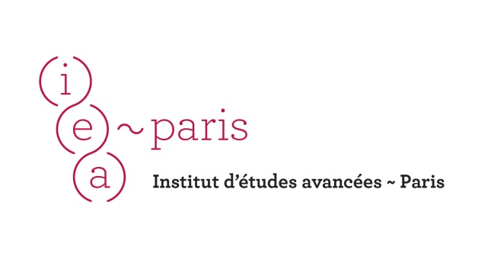
Co-Ethnics as Unwanted Others
Intra-Group Tensions After the Fall of Communism: Causes, Consequences, and Contexts

International workshop – June 20, 2014

Paris Institute for Advanced Studies
Quai d’Anjou, 75004 Paris, FRANCE

Organizer – Natalya Kosmarskaya
(IEA resident 2014/Institute of Oriental Studies, Russian Academy of Sciences

PROGRAMME

9.30-9.50 Welcoming Address of Gretty Mirdal (IEA Director) and Natalya Kosmarskaya

Session I. Thinking Theoretically and Comparatively About Co-Ethnics' Interaction (9.50-11.00)
Chair – Natalya Kosmarskaya

Jasna Čapo Žmegač (Institute of Ethnology and Folklore Research, Zagreb, Croatia)
Some Conceptual Issues: Comparisons Derived from Several Sub-Fields of Migration Studies (9.50-10.30)

Ekaterina Protassova (Dpt. of Modern Languages, University of Helsinki, Finland)
Russian Germans and Russian Finns in their Homelands: Comparing Levels of Integration (10.30-11.10)

Coffee-break (11.10-11.30)

Session II. Exploring Divisions within Co-Ethnic Migrant Communities (11.30-12.50)
Chair – Jasna Čapo Žmegač

Sergiu Gherghina (Dpt. of Political Science, Goethe University, Frankfurt, Germany)
Strangers amongst Us: Attitudes within Romanian Migrant Groups in Western Europe (11.30-12.10)

Oxana Morgunova (International Migration and Gender Research Institute, Brussels, Belgium)
From Brotherhood to Competitive Advantage: Intra-Group Tensions among Russian-Speaking Migrants in Britain (12.10-12.50)

Lunch (12.50-14.00)

Session III. Co-Ethnics in their "Homelands": Dilemmas of (Ethnic) Belonging and Experiences of Otherness under Different Social and Political Settings (14.00-16.40)
Chairs – Moya Flynn and Jasna Čapo Žmegač

Nona Shakhnazaryan (Centre for Independent Social Research, St. Petersburg, Russia)
The Integration of Armenian Refugees from Azerbaijan in Armenia and Nagorno-Karabakh (14.00-14.40)

Aida Aaly Alymbaeva (Max Plank Institute for Social Anthropology, Halle, Germany)
Between Minority and Majority: Sart-Kalmaks in Kyrgyzstan (14.40-15.20)

Zana Vathi (Dpt. of Social Sciences, Edge Hill University, UK)
Double Racism: Experiences of Otherness and Exclusion among Albanian Migrants and their Children Upon Return to Albania (15.20-16.00)

Aleksandra Djurić-Milovanović (Institute for Balkan Studies, Serbian Academy of Sciences and Arts, Belgrade, Serbia)
"Converted" Co-Ethnics: Romanian Migrants in the Northern Serbian Province of Vojvodina (16.00-16.40)

Coffee-break (16.40-17.00)

Session IV. Intra-Ethnic Tensions under Conditions of Labour Migration: A Case-Study of Central Asia (17.00-18.20)
Chair – Natalya Kosmarskaya

Moya Flynn (Central and East European Studies, University of Glasgow, Glasgow, UK)
Constructing the "Other" in Post-Soviet Bishkek: Perspectives of Long-term Residents and Migrants (17.00-17.40)

Igor Savin (Institute of Oriental Studies, Russian Academy of Sciences, Moscow, Russia)
Kazakhstani Uzbeks' Perceptions of Co-Ethnic Migrants from Uzbekistan and Kyrgyzstan (17.40-18.20)

Concluding Remarks (18.20-18.50)

